Français 10

Studio Créateur

La Tâche Finale

Criterion C (Communicating) and D (Using Written Language):

The final project is an individual one. You will create a poster or PowerPoint (see me about other format ideas) that compares two images. These can be photos, paintings, murals, your own art, etc. Follow these steps to finish your project:

1. Choose two interesting and complex images.
2. Describe each image in detail.
   1. What do you see in the image?
   2. What colours have been used?
   3. Describe the lines and shapes that you see.
   4. How does the image make you feel?
   5. What is the mood of the image and how do the lines and colours contribute to this mood?

3. Compare the images in terms of their similarities and differences.

The description and comparison can be done as one large paragraph or three separate paragraphs. This is up to you and is largely dependent on your choice of format.

Please hand in a hard copy to me of all your written work.

Grammatical criteria are as follows:

* Colour vocabulary
  + Different shades and tones
  + Types of colours (primary colours, cold colours, etc.)
* Lines
* Shapes
* Comparisons
  + Plus que
  + Moins que
  + Aussi que

The due date for the project is _________________________________________.

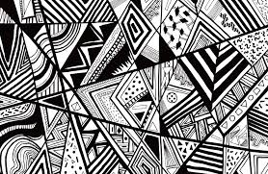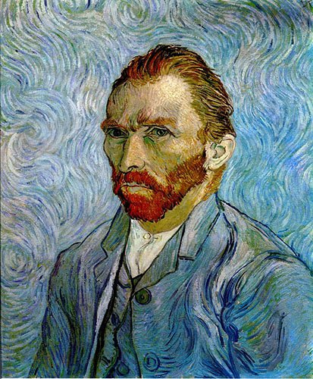

**VS**

Criterion D: Using Language (spoken)

You will be presenting your poster or PowerPoint through a gallery walk.

*Do not read your writing.

Prepare the details of your presentation ahead of time and speak conversationally to the person visiting you.

The visitor will also be evaluated on their comments or questions they make to show they are paying attention and understanding.

Evaluation will be based on:

* Communication
* Comprehension
* Pronunciation

*Record your conversations as you present.

*Send me your BEST conversation and label the file with your name. ([klouie@sd38.bc.ca](mailto:klouie@sd38.bc.ca))

Helpful expressions to explain how it makes you feel or what it means:

|  |  |
| --- | --- |
| Ça me fait penser de _____________ parce que ______________________________. | This makes me think of _____because______________. |
| Je me sens ______________ (à l’aise, troublé, etc.) parce que _____________________________. | I feel ___________because_________. |
| Ça m’inspire parce que ___________________________. | It inspires me because_________________. |
| Ça répresente __________________________. | It represents _____________. |
| Ça démontre ___________________________. | It demonstrates ____________________________. |
| Pour donner l’impression de/d’…, on utilise______________________ | To give the impression of…, it uses ________________ |
| Pour communiquer…. | To communicate…, |
| Pour démontrer… | To demonstrate…., |
| Pour suggérer… | To suggest…, |
| Pour indiquer… | To indicate…., |
| Other useful vocabulary: |  |
| Humeur | mood |